**ASSIGNEMT-14**

**EMPLOYEE ID:** 46248061.

**Question-1:**

**CDS_VIEW_NAME:** Z8061_DAY14_CDS1

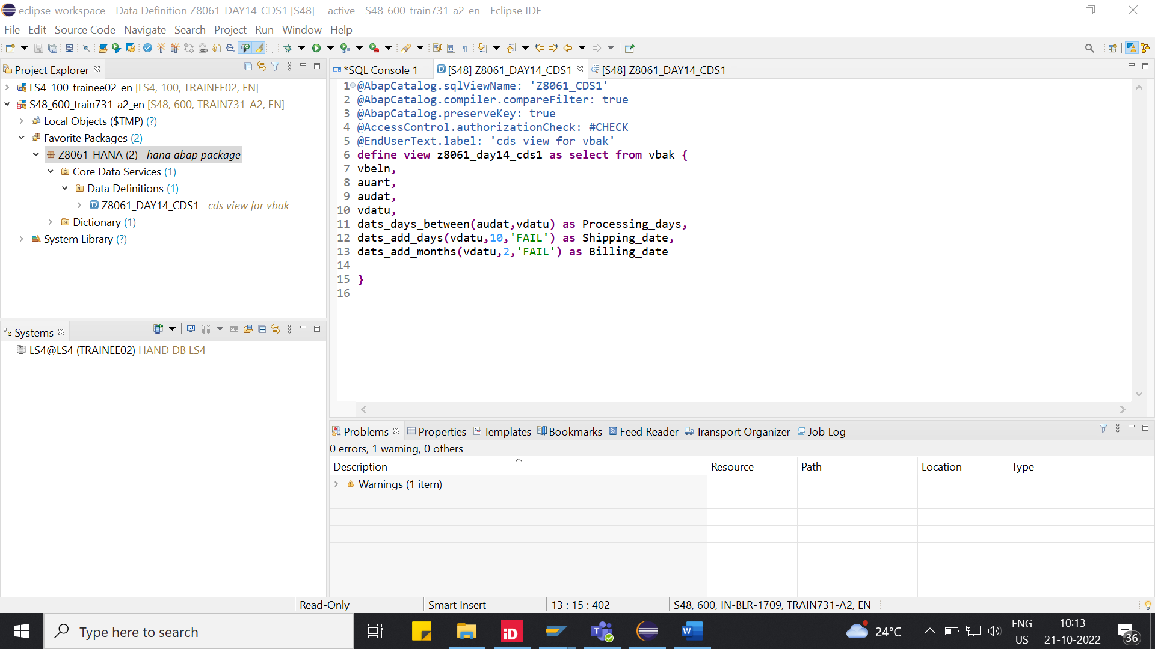

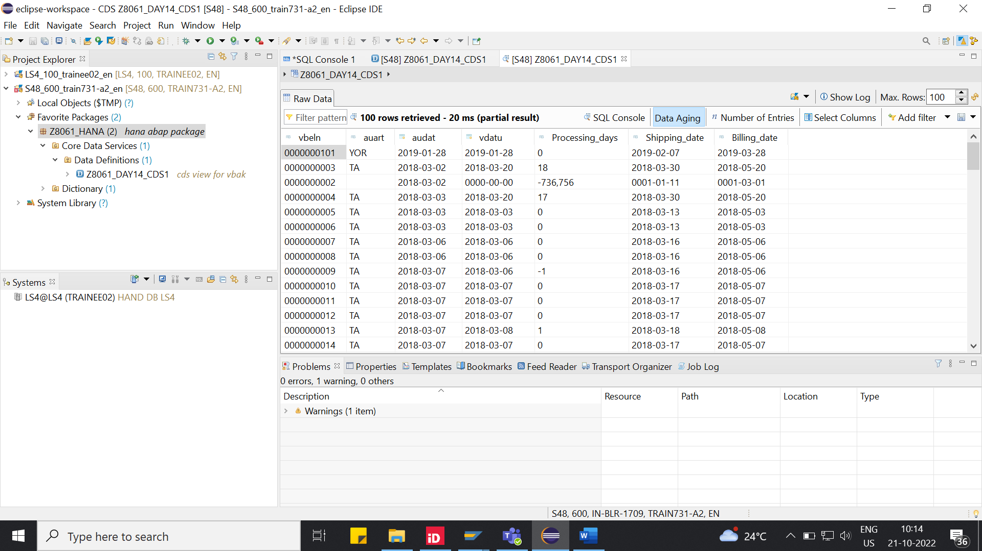

**Question-2:**

**CDS_VIEW_NAME:** Z8061_DAY14_CDS2

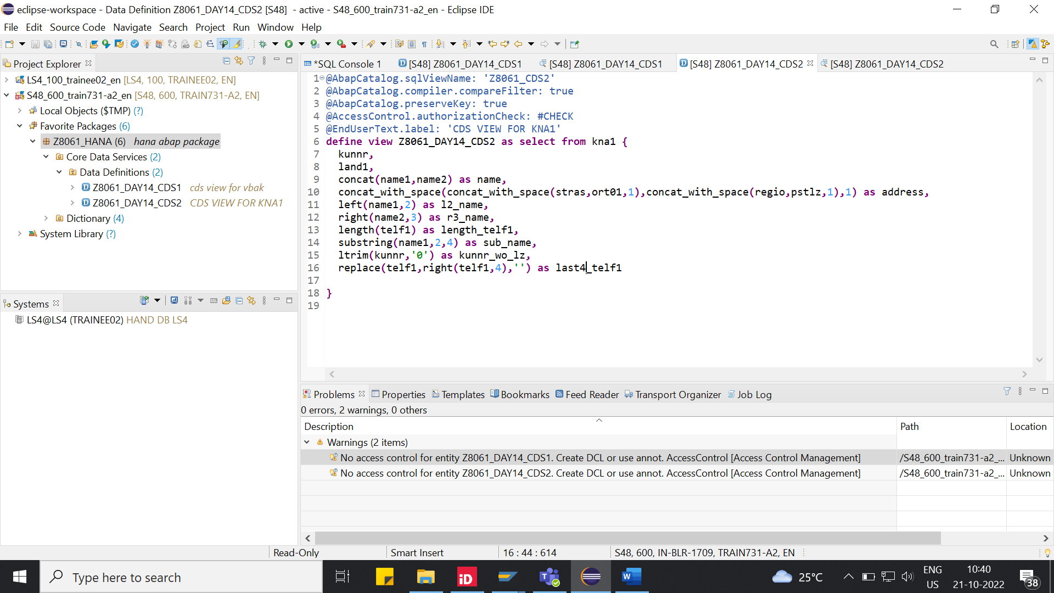

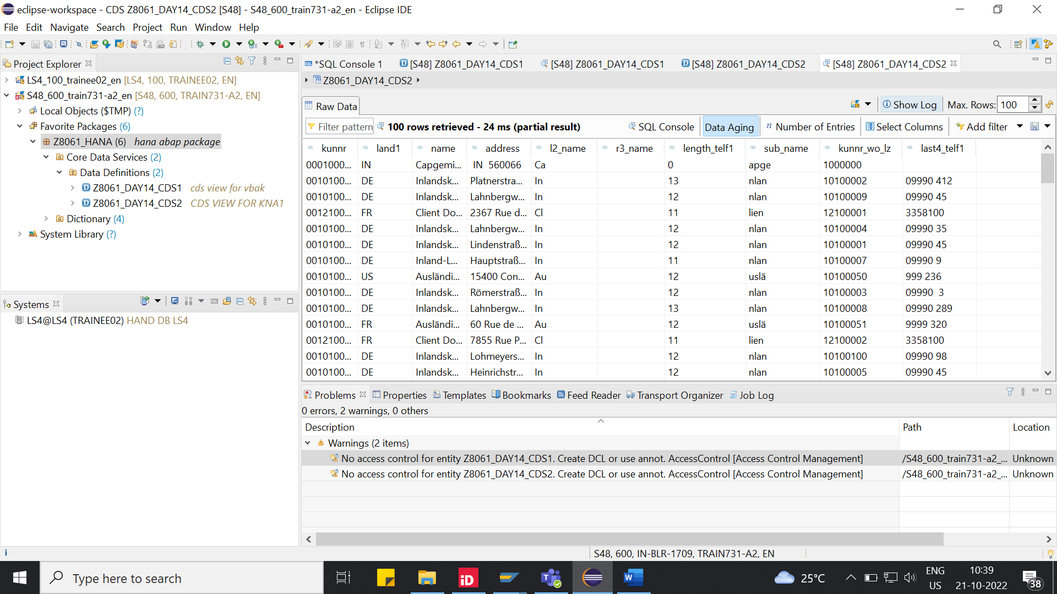

**Question-3:**

**CDS_VIEW_NAME:** Z8061_DAY14_CDS3 (with parameters).

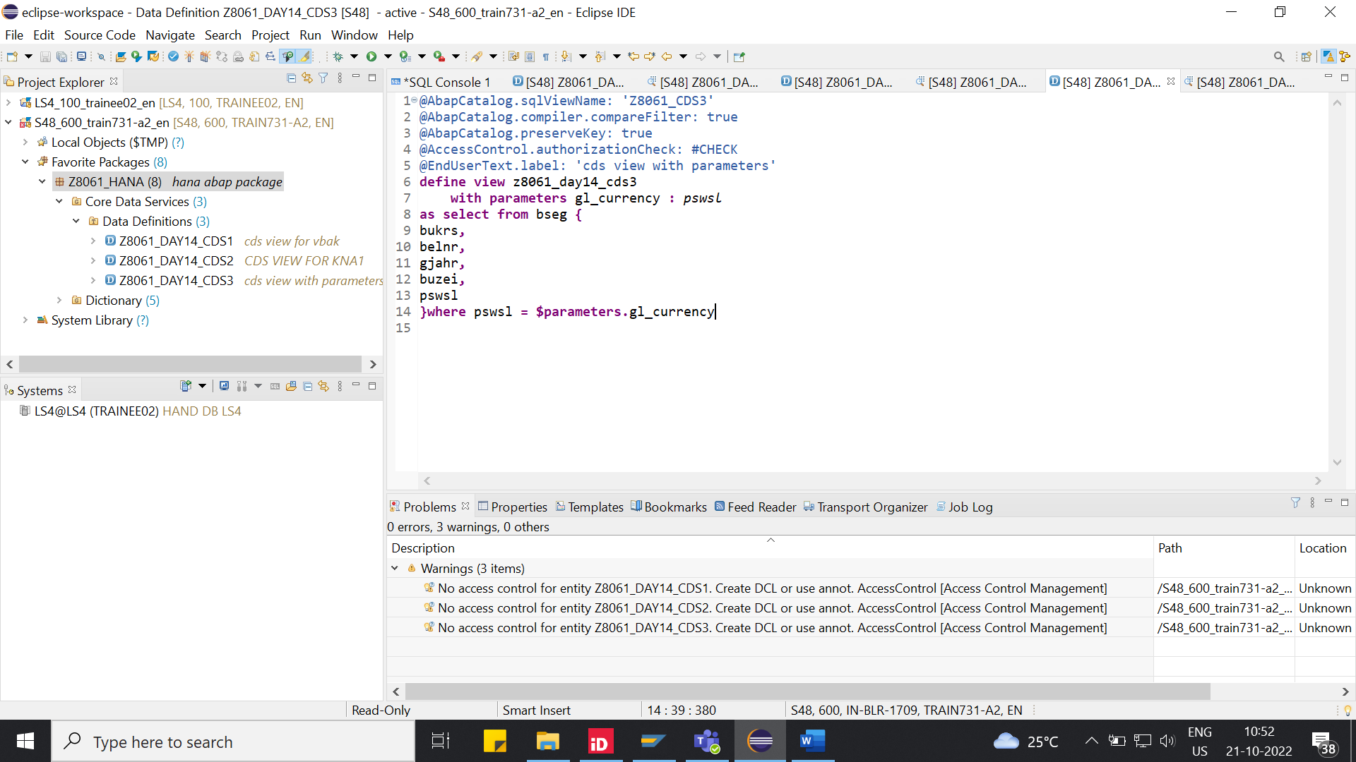

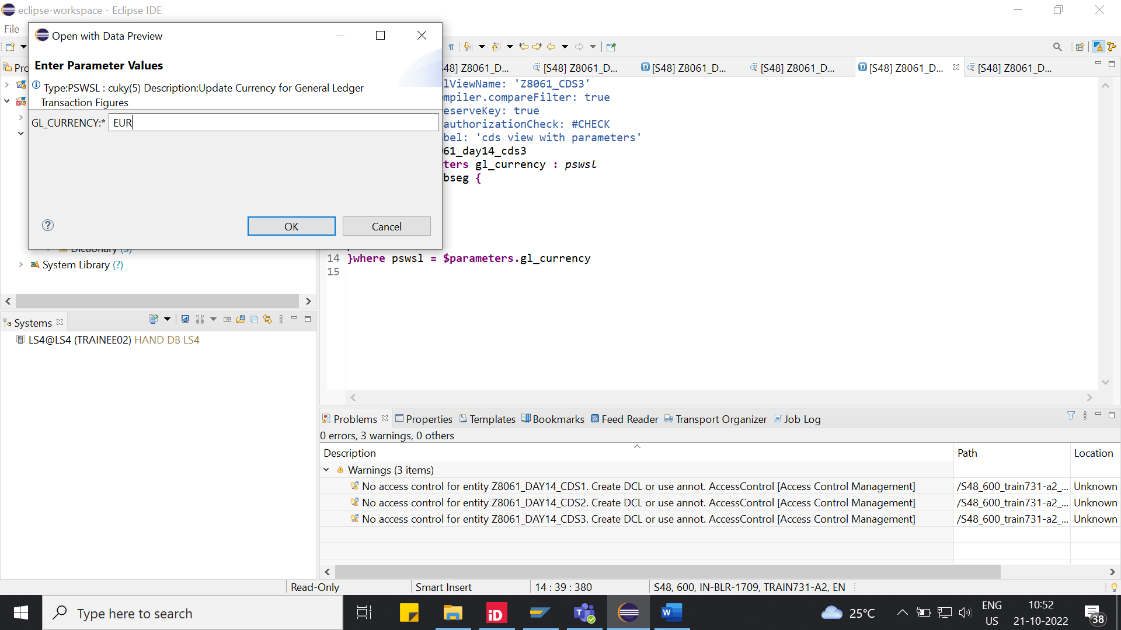

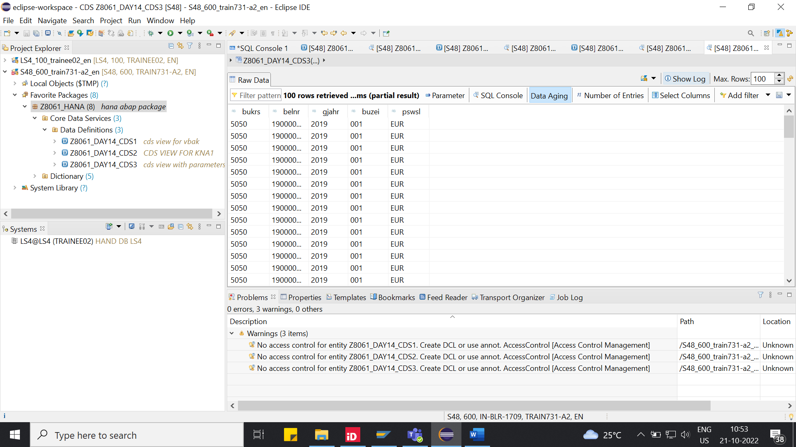

**Question-4:**

**AMDP_CLASS_NAME:**  Z8061_AMDP1.

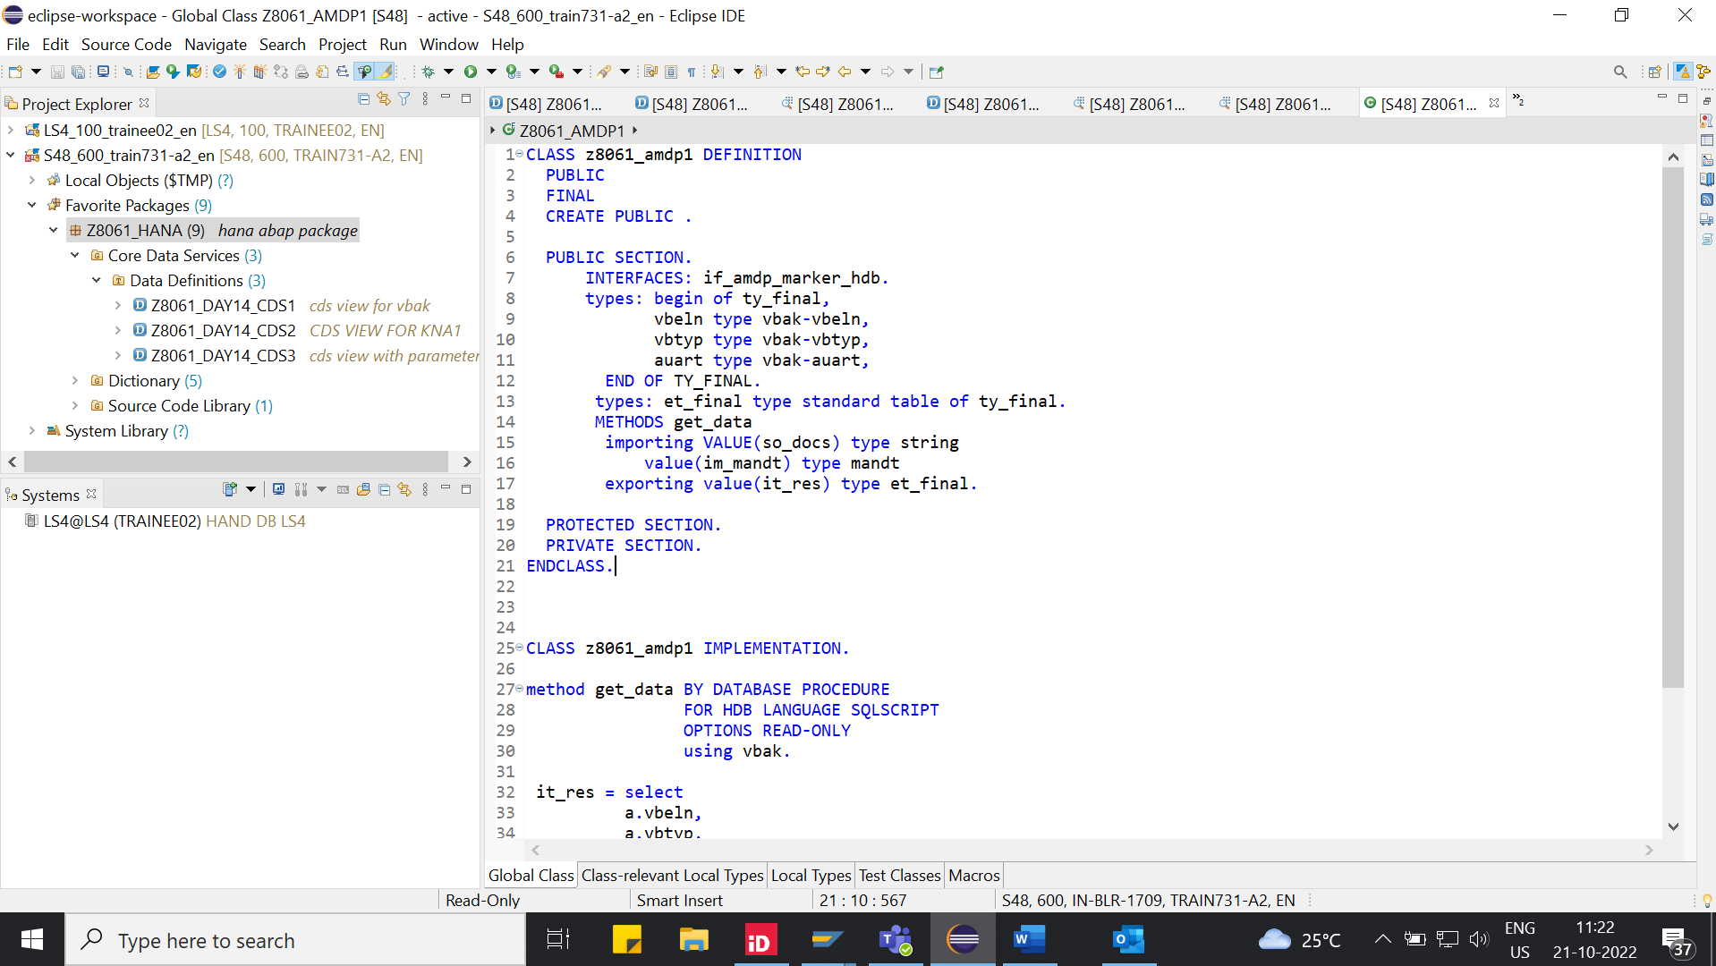

**ABAP_PROGRAM:** Z8061_DAY14_AMDP1.

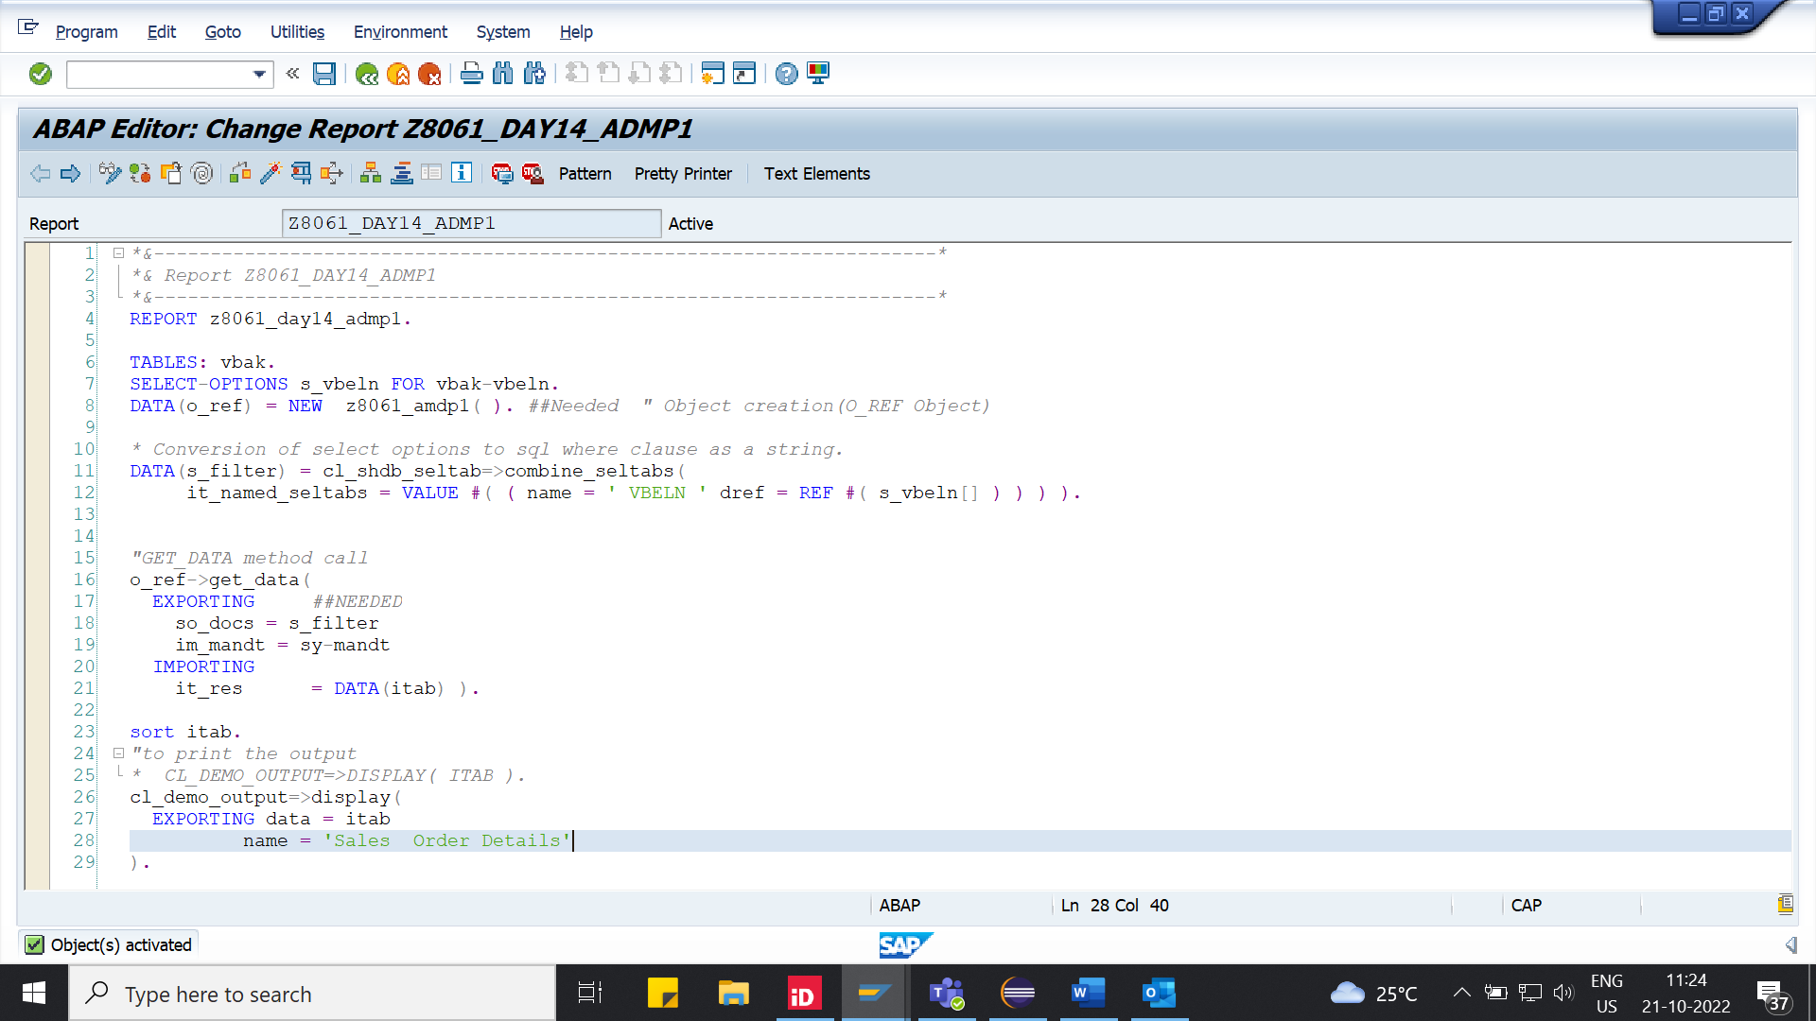

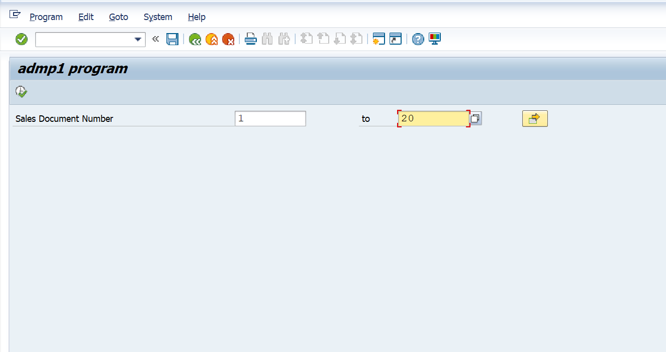

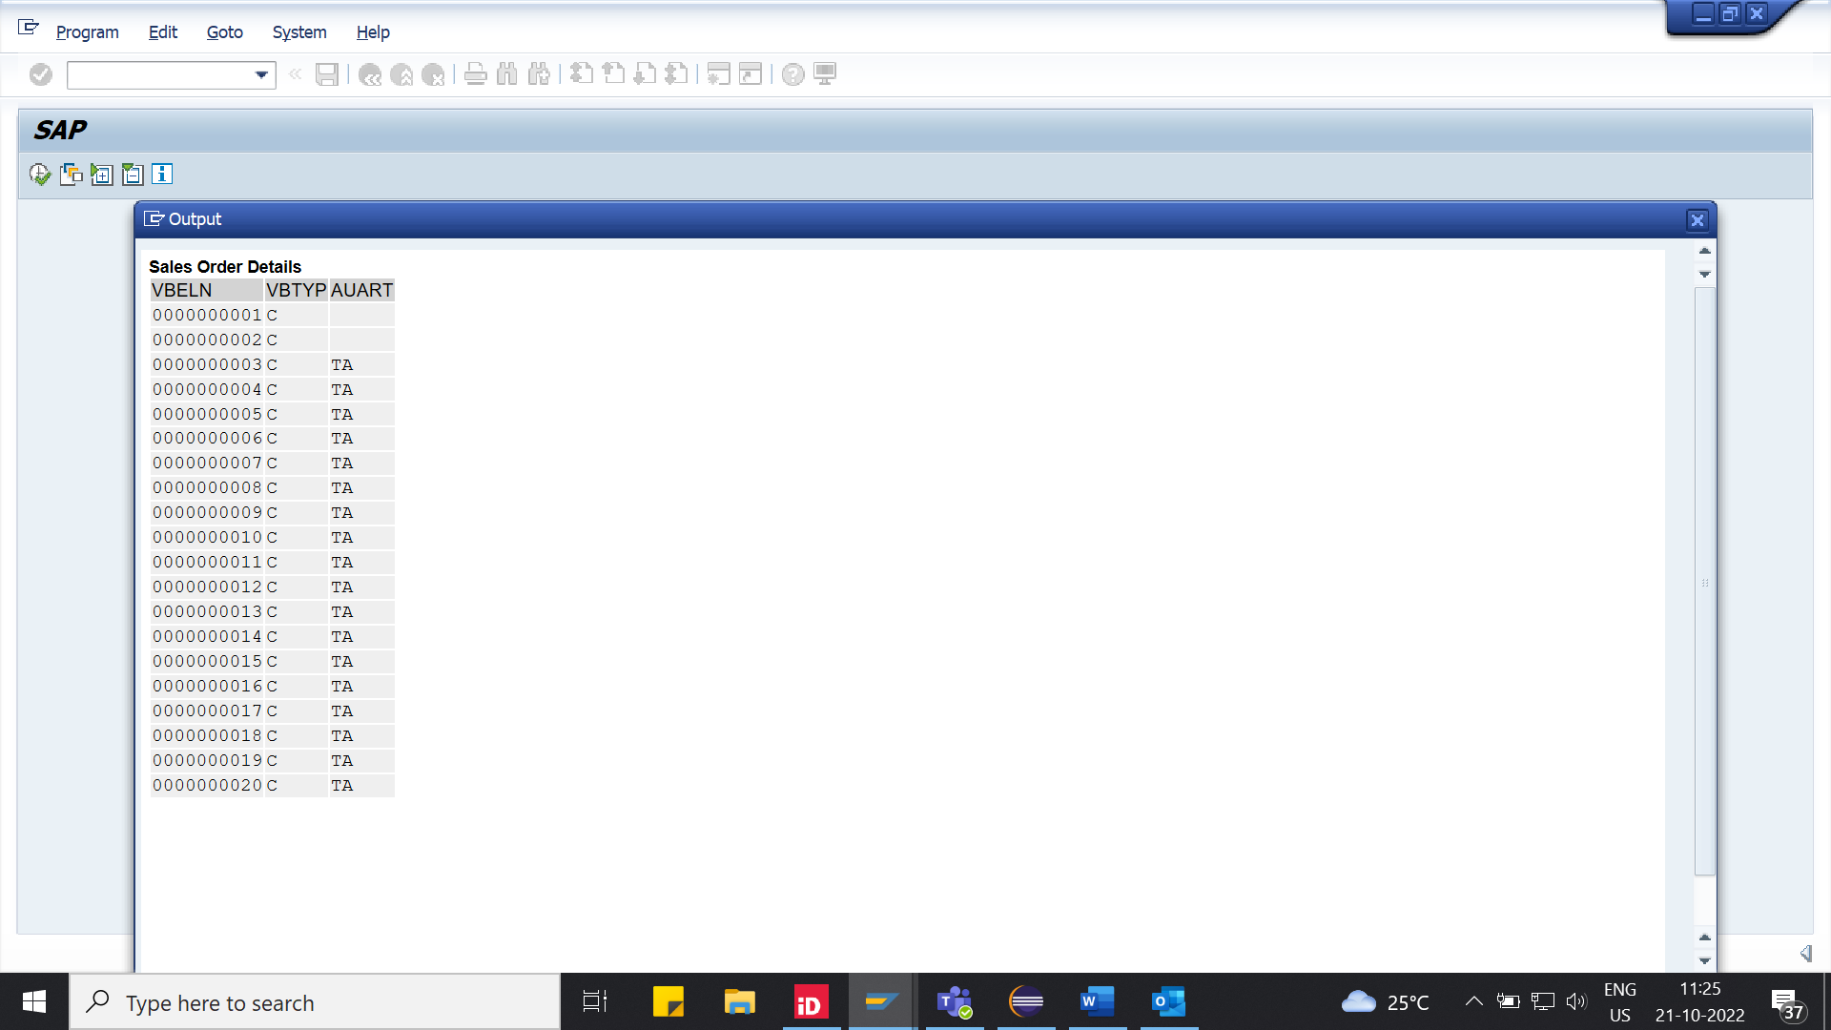

**Question-5:**

**AMDP_CLASS_NAME:**  Z8061_AMDP2.

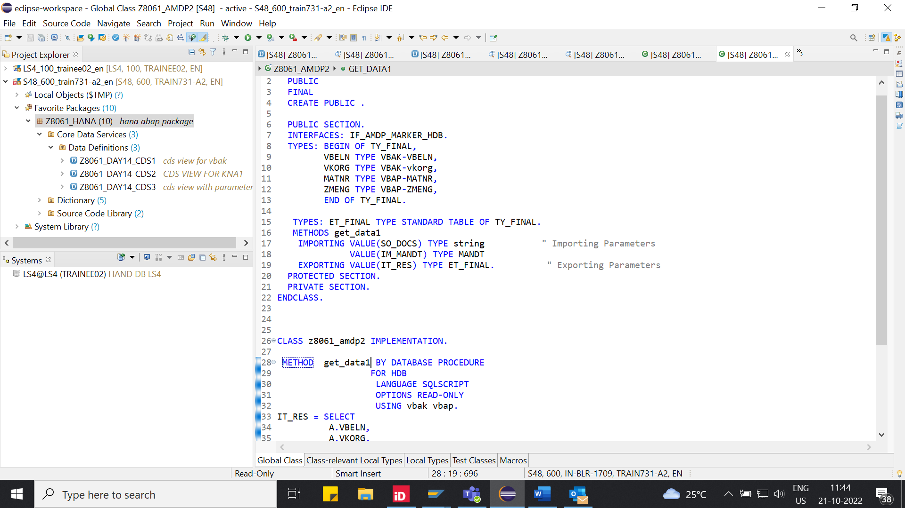

**ABAP_PROGRAM:** Z8061_DAY14_AMDP2.

